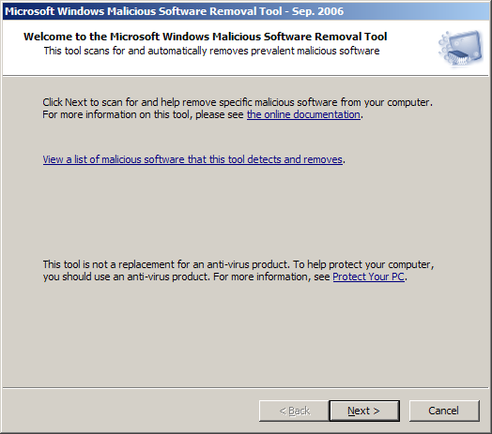
Summary
This tool shows up in Windows Update all of the time. Personally, I think it's a very responsible thing for Microsoft to do, but I don't think it can quite compare to other things like Ad-Aware, Spybot Search & Destroy, and so on. This program probably would be great for the average user, but for the power user like myself that often gets paid to remove spyware, it doesn't find enough malicious software.

